Mobile Application for Young Mother

Anastasia Repina
Faculty of Computer Science, Department of Software Engineering, Higher School of Economics
Moscow, Russia
Email: aarepina@edu.hse.ru

Abstract—Nowadays there are a lot of different health and nutrition applications made for different platforms. The majority of them solve only one particular problem – they just collect and systemize the information of the newborn’s health. However, mother’s health is not less important as it is highly linked to baby’s wellbeing. Mobile Application for Young Mother is an Android application which provide interface for baby health and development monitoring as well as has function for looking after mother’s health. It stores, analyzes and presents information in a convenient way to its main user – young mother and can tell her if there will be something wrong.
Keywords—application, android, mother, baby, health.

Introduction
Mobile applications have seen a huge growth during the last few years (Kratzke and Cox, [1]). We encounter its uses constantly in many different spheres. Now everything can be done online with the help of a great variety of applications. It is possible to order food, play games or talk with friends and relatives without spending time on going from one place to another. This success can be attributed to the emergence of new special tools which can be linked to your mobile phone as well as the emergence of new functions inside the device itself.
The most important part of every person’s life is his or her health. Even 15 years ago, it was impossible to imagine that health monitoring would be possible through a mobile phone. Wearable devices and mobile phone health apps can and will change health care by empowering users and educating them to take control of their health. The biggest world companies are now working on mobile applications and new devices which will help the human society to live longer and healthier. The main plus of the mobile applications is its portability. You can take phone inside your pocket everywhere, so health and nutrition monitoring is just a couple of clicks away.
It is also clear that certain periods of life cycle for, example, the phase after the birth of child, may affect the level of phone usage. One survey of 203 women found that 94 percent reported that smartphone technology had changed their life for better, with 65 percent reporting that they had downloaded pregnancy apps, with an average of three being downloaded during the gestation period (Derbyshire and Dancey, [2]).
Google Fit [3] is a big health-tracking platform which was developed by Google company for the Android operating system. It positions itself as an integrator (Gay and Leijdekkers, [4]). Google Fit provides a set of APIs that blends data from multiple apps on user’s devices using sensors. Despite many similar projects, Google Fit stands out because of its reputation for easily uploading all the necessary data with the help of educational material and tutorials. The platform is widely used in health and nutrition studies and collection by researchers and developers around the world. Since the toolkit is fastidiously documented and has a bunch of tutorials, the platform serves an important educational purpose and is the ultimate guide for novices in the field of health monitoring.
In this paper, literature review is provided in the second section where comparison of relevant competitor applications in the field can be found. The third section presents the survey brief description. The architecture of the work as well as the design of the application are mentioned in the fouth section. The fith section outlines the practical applicability of the work.

Related Work

- Applications Comparison
Application name | Price (₽) | Baby’s health monitoring | Mother’s health monitoring | Data analyses | Wearable data collection | Stability | Timetable
Health Kit [5] | free | - | + | + | + | + | -
Baby diary [6] | free | + | - | - | - | + | +
Baby Connect [7] | 159 | + | - | + | - | + | +
Ya rodilsya [8] | 149 | + | - | + | - | + | +
FirstYear [9] | free | + | - | + | - | +/- | +
Mi Fit [10] | free | - | + | + | + | - | -
This work | free | + | + | + | + | + | +
Although this project’s application draws from already existing works in the field of health monitoring and nutrition, it introduces a combination of the distinctive useful functions and novel ideas.
The related works review was done not only for Android platform, but also for IOS one in order to make the review more complex. There were 7 features which was evaluated in each app: the price, existence of baby’s and mother’s health monitoring, functioning stability, timetable availability, collection the information from wearable devices and.
As can be seen from Table I, the mobile application which will be created during this work is better than its main competitors, as they have bounded functional and have problems with stable performance. Furthermore, this work will have monitoring systems of both newborn’s and mother’s health. It is also important that the price of the application is free as profit gaining is not included in the tasks of the app which is being developed.

Survey
Before the app development has started it was important to understand which functions it should include and which are not necessary. There are a lot of different health and nutrition parameters, so this preparation step was necessary.
In order to do the task, the young parents survey with the help of Google Forms service was created. The questionnaire consisted of four parts, each of them included not only of the prepared answers, but also had a space for those reviewers who did not find the suitable one. The survey was completed by 40 persons, and after it was carefully analyzed, the functions of the future application as well as the main development vector was identified.

The architecture And design of the application
The mobile application is made for Android operating system. According to the IDC Quarterly Mobile Phone Tracker [11], phone companies shipped a total of 344.3 million smartphones worldwide in the first quarter of 2017 (1Q17). The Android's share of the smartphone market is continuing to capture roughly 85% of the worldwide smartphone volume. It consists of several modules which send and receive the information from the application (Fig 1. Application’s main modules).
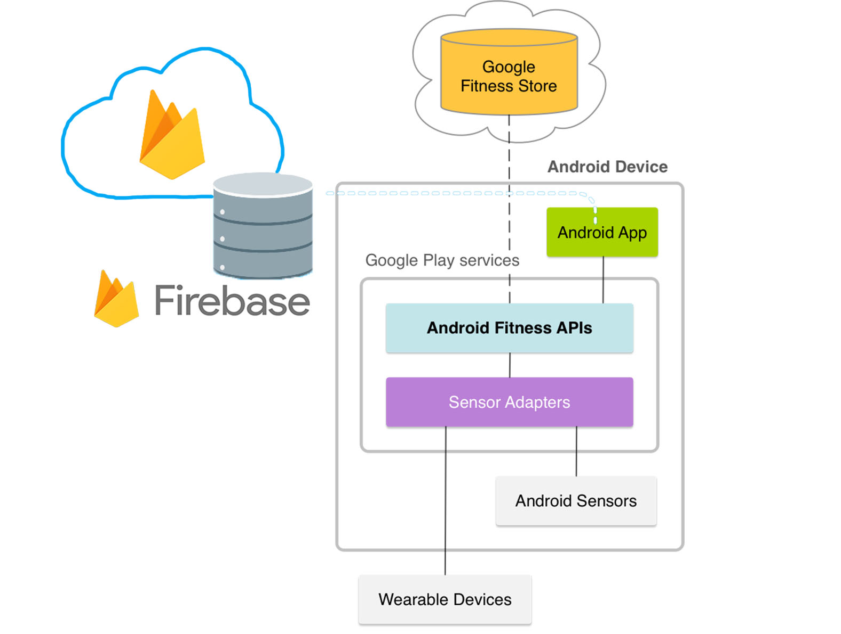
- Application’s main modules.
The app provides an interface for adding the data connected with newborn’s health and development as well as has the connection to Google Fit where the mother’s statistic is being collected from bands and other monitoring devices. All the functions are mentioned below.

Application Main Functions
- Diary with all the baby’s health and nutrition information (Uploaded by mother):
  - Height and weight.
  - Nutrition.
  - Sleep.
  - Diapers.
  - Ilnesses, sympthomes, pills, vaccinations.
  - Outdoor walks.
  - Notes.
- Diary with important mother’s health and nutrition information (Uploaded with the help of Google Fit).
  - Nutrition.
  - Sleep.
  - Calories.
  - Steps.
  - Weight.
- Data analytics for dynamics monitoring.
- Notifications.
- Health reports creation.
All the collected data is saved with the help of the Google Firebase service [12] which provides a free realtime database for developers. This will help user’s if they lose their phones or just buy a new one. The already added data will be uploaded from Firebase straight to the app. The Firebase database consists of several tables which have their own fields. This tables have analogues in the application which are being connected with the help of API. All the tables relations can be seen on Figure 2. Application’s database.
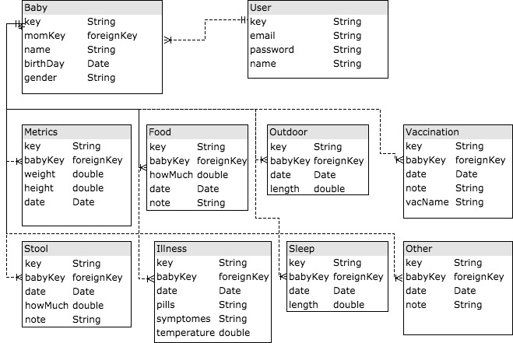
- Application’s database.
The application itself consists of several pages. Each on them provide information connected with it’s own specific function from the list above. The main page combines four tabs: baby’s diary, mother’s diary, analitics and settings. It is important to make the appearance of an app attractive, so the work is using icons with the help of Flaticon Basic License.

Practical Applicability
New programs are being created in order to promote healthy lifestyle as well as to solve specific problems with the help of mobile apps. World biggest companies are making their own commitments in the common cause. Such commitments appear to be rising. Johnson & Johnson company has invested $200 million for a five-year program which main target is expectant and new mothers in the developing countries, a significant portion of which will be focused on a program called Mobile Health for Mothers (Reuters, [13]). That is why the practical applicability of this specific work is beyond doubt. It provides user-friendly interface and has the functions which will really help to improve people’s lives in the health and nutrition field.

Conclusion
Mobile applications for health and nutrition monitoring are widely used. However, when the app’s main sphere is newborn’s development and well-being the majority part of them do not look after mother. The developers forget that the mother’s health is as important as the baby’s one, so it is necessary to include functions which will help the young parent to stay healthy and recover fast after the childbirth as well. In that situation, even one saved hour can be used profitably by mom. The main idea of the work is to create a mobile application which helps the mother to stay informed about her and her baby’s health and track the development and nutrition as well. With the help of the most popular and widely-used modern technologies the main goal of this project will definitely be achieved.
The proposed project is a significant advance for the health and nutrition applications and contributes to the dissemination of contemporary complex approaches to human’s wellbeing monitoring. Considering the rapid growth of such apps in the market, this work is of great importance, since it will serve the mentioned problems which already exist in the applications and will become a real helper for young parents.

References
- Kratzke Cynthia, Cox Carolyn, 2012. Global Journal of Health Education and Promotion. Urbana Vol. 15, Iss. 1, p. 72-82.
- Emma Derbyshire, Darren Dancey, 2013. Smartphone Medical Applications for Women’s Health: What Is the Evidence-Base and Feedback? International Journal of Telemedicine and Applications, vol. 2013, Article ID 782074, 10 pages.
- Google Inc., Health-tracking platform, 2018. [Online] Available: https://www.google.ru/intl/en_en/fit/ [Accessed: 5 January 2018].
- Valerie Gay, Peter Leijdekkers, 2015. Bringing Health and Fitness Data Together for Connected Health Care: Mobile Apps as Enablers of Interoperability. J Med Internet Res. Nov; 17(11): e260.
- Apple Inc., Health informatics mobile app, 2018. [Online] Available: https://www.apple.com/ru/ios/health/ [Accessed: 5 January 2018].
- BabyJoyApp, Child’s growth and development mobile app, 2018. [Online] Available: https://play.google.com/store/apps/details?id=com.babyjoy.android [Accessed: 5 January 2018].
- Seacloud Software, Child’s growth and development mobile app, 2018. [Online] Available: https://play.google.com/store/apps/details?id=com.seacloud.bc [Accessed: 5 January 2018].
- Nikitin S., Child’s growth and development mobile app, 2018. [Online] Available: https://itunes.apple.com/ru/app/a-rodilsa/id477391124?l=en&mt=8 [Accessed: 5 January 2018].
- Ding Y., Child’s growth and development mobile app, 2018. [Online] Available: https://itunes.apple.com/ru/app/firstyear-baby-feeding-timer-sleep-nappie-log/id645810513?l=en&mt=8 [Accessed: 5 January 2018].
- Anhui Huami Information Technology Co.,Ltd., Health informatics mobile app, 2018. [Online] Available: https://play.google.com/store/apps/details?id=com.xiaomi.hm.health [Accessed: 5 January 2018].
- IDC Corporate USA, Worldwide Quarterly Mobile Phone Tracker, 2017 Q1. [Online] Available: https://www.idc.com/tracker/showproductinfo.jsp?prod_id=37 [Accessed: 12 January 2018].
- Google Inc., Mobile and web application development platform, 2018. [Online] Available: https://firebase.google.com/ [Accessed: 5 January 2018].
- Reuters, 2010, J&J Launches Aid Program for Mothers, 9 September.

1507 words

